**Survival Analytic**

Patient Data

**Package used in R:**

Survminer : Used to Plot the curve for Survival Analytic

Survival : Used to KaplanMeierFitter Model

**Package used in Python** :

Pandas :For Data Manipulation

From Lifelines import KaplanMeierFitter : Used to Run KaplanMeierFitter Model

**Loading the data**

Loading the Patient dataset in R and Python.

**EDA**

No NaN Data Found in the dataset

PatientID : Name (Nominal Data not very important)

Followup : Time (New Value created as Time or T for Analytic)

Eventtype : Event (New Value created as Time or T for Analytic)

Scenario: Group (Everyone are from same group)

## **Survival Analytic : Survival Curve Plot**

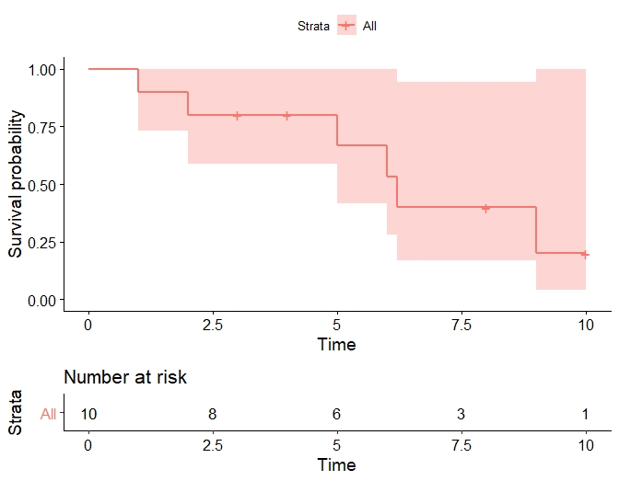

From the plot , **Time 2 to 5 and 6.2 to 9** they was a steady observation of no death and the survival period has been extended.

* From Time 2 to 5 has high survival Probability with steady survival Rate
* From Time 5 to 6.2, they was a frequent survival fall and survival rate reduced significantly
* Then from Time 6.2 to 9 has low survival Probability with good survival rate